Monday, February 4, 2019

CHAPTER 17

P.P.17.1 T = 2, ω_{o} = 2π/T = π

f(t) = 1, 0 < t < 1
–1, 1 < t < 2

a_{o} = = 0.5(1 – 1) = 0

a_{n} =

= = 0

b_{n} =

=

b_{n} = 4/(nπ), for n = odd
= 0, for n = even

f(t) = n = 2k – 1

See Fig. 17.6 for the spectra.

P.P.17.2 T = 1, ω_{o} = 2π/T = 2π, f(t) = 6t, 0 < t < 1.

a_{o} = = = 3

a_{n} =

=

= = 0

b_{n} =

= = –6/(nπ)

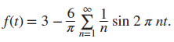

P.P.17.3
f(t) = 8, –π < t < 0
–8, 0 < t < π

f(t) is an odd function, a_{o} = 0 = a_{n}

T = 2π, ω_{o} = 2π/T = 1

b_{n} =

=

= –32/(nπ), n = odd
0, n = even

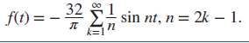

P.P.17.4 f(t) = 8t/π, 0 < t < π, T = 2π, ω_{o} = 1

This is an even function, b_{n} = 0.

a_{o} = 4

a_{n} =

=

=

= –32/(n²π²), n = odd
0, n = even

f(t) = , n = 2k – 1

P.P.17.5 f(t) = 5t/π, 0 < t < π, ω_{o} = 2π/T = 1

This is half-wave symmetric. For odd n,

a_{n} =

=

=

= –20/(n²π²), n = odd
0, n = even

b_{n} =

= , n = odd

Thus, f(t) = , n = 2k – 1

P.P.17.6
v_{s}(t) = 1.5 – (3/π), ω = 2πn

v_{o}(ω) = (1/(jωC))v_{s}/(R + (1/jωC)) = v_{s}/(1 + jωRC) = v_{s}/(1 + j2ω), RC = 2

For the DC component (ω = 0, or n = 0), v_{s} = 1.5 and v_{o} = 1.5

For the nth harmonic, v_{s} = –(3/(nπ)) or

v_{o} = –(3/(nπ))/∠tan^{–1}2ω

or v_{o} = –3∠(– tan^{–1}2ω)/(nπ)

Hence, v_{o}(t) = 1.5 – (3/π)sin(2πnt – tan–1(2ω))

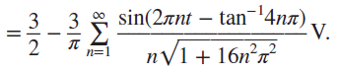

P.P.17.7
v(t) = (1/3) + (1/π²)

= (1/3) + (1/π²) cos(nt - φ_{n})
where A_{n} = =

φ_{n} = tan^{–1}(b_{n}/a_{n}) = tan^{–1}(–nπ)

v(t) = (1/3) + cos[nt – tan⁻¹(–nπ)]

Z = 2 + 1||(1/(jω)), ω = n

= 2 + (1/(jω))/(1 + (1/(jω))) = 2 + (1/(1 + (jω))

= (3 + 2jω)/(1 + jω), ω = n

= (3 + j2n)/(1 + jn)

I = V/Z = [(1 + jn)/(3 + j2n)] V

2 Ω

1 Ω

V(ω)

+
−

1/jω

I

I_{o}

By current division, I_{o} = (1/jω)I/[1 + (1/jω)] = I/(1 + jω) = V/(3 + j2n)

For the DC component (n = 0), V = 1/3 and I_{o} = V/3 = 1/9

For the nth harmonic, V = [1/(n²π²)]∠–tan^{–1}(–nπ)

I_{o} = V/[∠–tan^{–1}(2n/3)]

= ∠[–tan^{–1}(–nπ)–tan^{–1}(2n/3)]/[n²π²]

But, tan^{–1}(–nπ) = –tan^{–1}(nπ)

In the time domain,
i_{o}(t) = (1/9) + cos(nt – tan^{–1}(2n/3) + tan^{–1}(nπ)) A

P.P.17.8 P = V_{DC} I_{DC} + 0.5V_{n} I_{n} cos(φ_{n} – θ_{n})
= 128(0) + 0.5(192)(4) cos(10°) + 0.5(96)(1.6) cos(30°)

= 378.2 +66.51

= 444.7 W

P.P.17.9 I²_{rms} = 8² + 0.5[30² + 20² + 15² + 10²]

= 64 + 0.5x1625 = 876.5

= 29.61 A

P.P.17.10 f(t) = 1, 0 < t < 1

= 0, 1 < t < 2

T = 2, ω_{o} = 2π/T = π

C_{n} = (1/T) = 0.5[ + 0]

= 0.5[1/(–jnπ)]e^{–jnπt} = [j/(2nπ)](e^{–jnπ} – 1)

But e^{–jnπ} = cos(nπ) – jsin(nπ) = cos(nπ) = (–1)^{n}

C_{n} = [j/(2πn)][(–1)^{n} – 1] = 0, n = even

= [–j/(nπ)], n = odd ≠ 0

For n = 0, C_{o} = 0.5 = 0.5

Hence, f(t) =

P.P.17.11 f(t) = t, –1 < t < 1, T = 2, ω_{o} = 2π/T = π

C_{n} = (1/T) = 0.5

= 0.5[e^{–jnπt}/(–jnπ)²](–jnπt – 1)|

= [–1/(2n²π²)][e^{–jnπ}(–jnπ – 1) – e^{jnπ}(jnπ – 1)]

= [–1/(2n²π²)][(cos nπ – j sin nπ)(–jnπ – 1) – (cos nπ + j sin nπ)(jnπ – 1)]

= [j cos nπ]/(nπ)

C_{n} = j(–1)^{n}/nπ, n ≠ 0

For n = 0, C_{o} = (1/T) = 0

Thus, f(t) =

|C_{n}| = 1/(nπ), n ≠ 0, θ_{n} = (–1)^{n} 90°, n ≠ 0

The amplitude and phase spectra are shown below.

0

|C_{n}|

n

4

3

2

1

–4

–3

–2

–1

0.32

0.8

0.32

0.16

0.16

0.11

0.11

0.8

3

1

–1

–3

–90°

90°

–2

–4

2

4

n

0

P.P.17.12 The schematic is shown below. The attributes of the voltage source is entered as shown. After entering the final time (5 or 6T), the Print Step, the Step Ceiling, and the Center Frequency in the transient dialog box, the circuit is saved. Once the PSpice is run, the output contains the following Fourier coefficients.

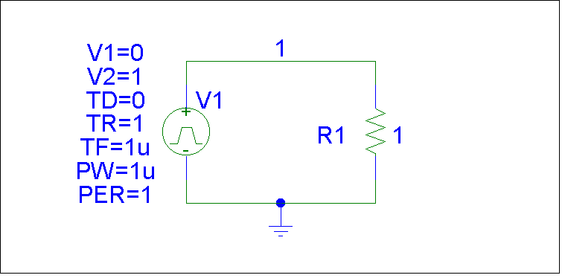

FOURIER COMPONENTS OF TRANSIENT RESPONSE V(1)

DC COMPONENT = 4.950000E-01

HARMONIC FREQUENCY FOURIER NORMALIZED PHASE NORMALIZED
NO (HZ) COMPONENT COMPONENT (DEG) PHASE (DEG)

1 1.000E+00 3.184E-01 1.000E+00 -1.782E+02 0.000E+00
2 2.000E+00 1.593E-01 5.002E-01 -1.764E+02 1.800E+00
3 3.000E+00 1.063E-01 3.338E-01 -1.746E+02 3.600E+00
4 4.000E+00 7.979E-02 2.506E-01 -1.728E+02 5.400E+00
5 5.000E+00 6.392E-02 2.008E-01 -1.710E+02 7.200E+00
6 6.000E+00 5.337E-02 1.676E-01 -1.692E+02 9.000E+00
7 7.000E+00 4.584E-02 1.440E-01 -1.674E+02 1.080E+01
8 8.000E+00 4.021E-02 1.263E-01 -1.656E+02 1.260E+01
9 9.000E+00 3.584E-02 1.126E-01 -1.638E+02 1.440E+01

TOTAL HARMONIC DISTORTION = 7.363360E+01 PERCENT

P.P.17.13 The schematic is shown below. Since T = 1/f = 0.55 ms, in the transient dialog box, we set Print Step = 0.01 ms, Final Time = 4 ms, Center Frequency = 2,000 Hz, Number of Harmonics = 5, and Output Vars = V(R1:1). Once the circuit is saved, we simulate it and obtain the following results.

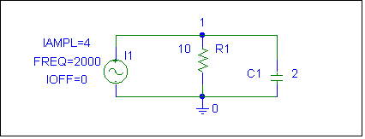

DC COMPONENT = -1.507149E-04

HARMONIC FREQUENCY FOURIER NORMALIZED PHASE NORMALIZED
NO (HZ) COMPONENT COMPONENT (DEG) PHASE (DEG)

1 2.000E+03 1.455E-04 1.000E+00 9.006E+01 0.000E+00
2 4.000E+03 1.851E-06 1.273E-02 9.597E+01 5.910E+00
3 6.000E+03 1.406E-06 9.662E-03 9.323E+01 3.167E+00
4 8.000E+03 1.010E-06 6.946E-03 8.077E+01 -9.292E+00

TOTAL HARMONIC DISTORTION = 1.830344E+00 PERCENT

From this, we use the amplitude and phase of the Fourier components to get

v(t) = –150.72 + 145.5 sin(4π ∙ 10³t + 90°) + . . . μV

P.P.17.14 From Example 16.14,

2ω_{o} = 4π = 12.566 rad/s
3ω_{o} = 6π = 18.84 rad/s
4ω_{o} = 8π = 25.13 rad/s
5ω_{o} = 10π = 31.41 rad/s
6ω_{o} = 12π = 37.7 rad/s

Since the ideal bandpass filter passes only 15 < ω < 25, it means that only the 3rd, 4th, and 5th harmonics will be passed. Hence,

y(t) = (–1/3π)sin3ω_{o}t – (1/(4π))sin4ω_{o}t – (1/5π)sin5ω_{o}t, ω_{o} = 2π

